OUTPUT:
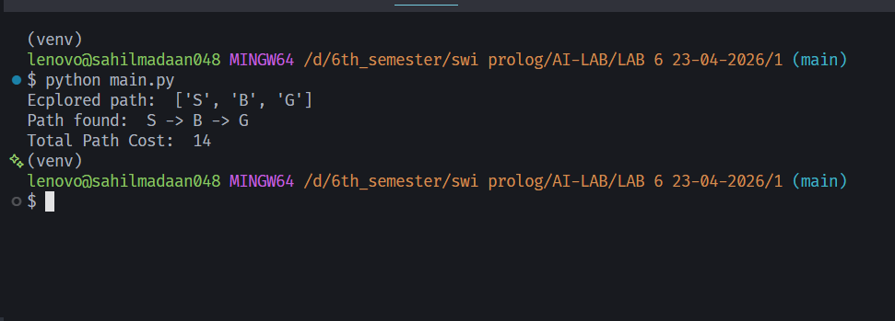

Lab 6
- Best First Search Traversal on a Graph
You are given a weighted graph with the following nodes:
S, A, B, C, D, E, G
Each edge has a step cost and each node has a heuristic value h(n) that estimates the distance to the goal node G.
Starting from node S, perform Best First Search (Greedy Search) to reach node G using the heuristic values h(n).
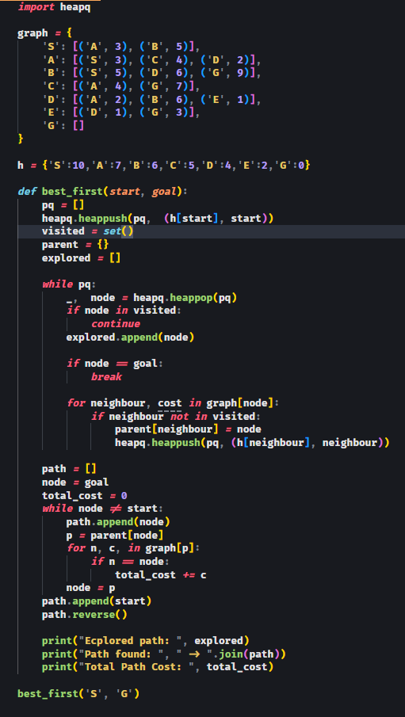

OUTPUT:

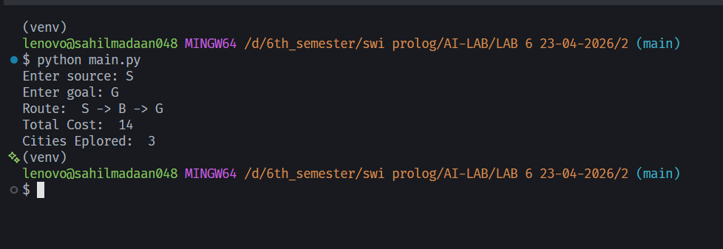

Lab 6
- Route Finding Between Two Cities
Using the same weighted graph and heuristic values provided in Program 1, implement a Best First Search algorithm to find a route between two cities.
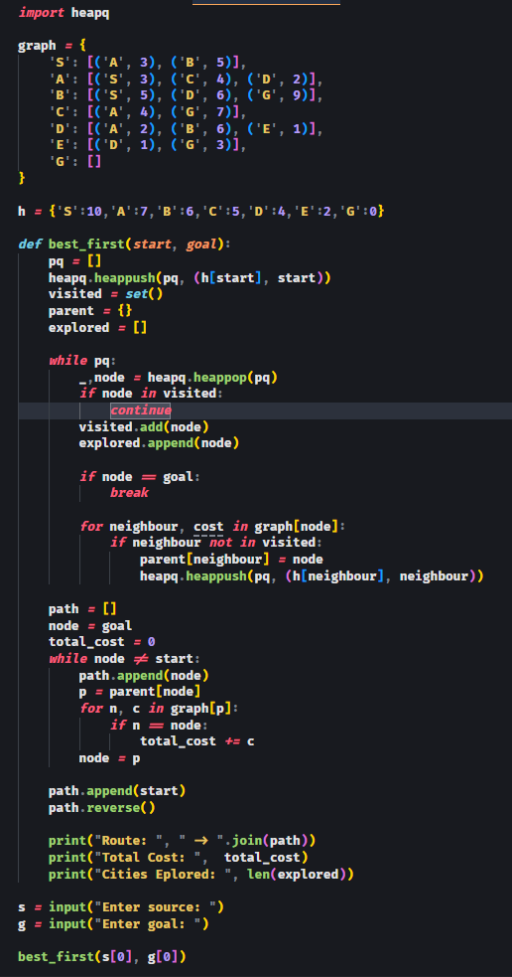

OUTPUT:

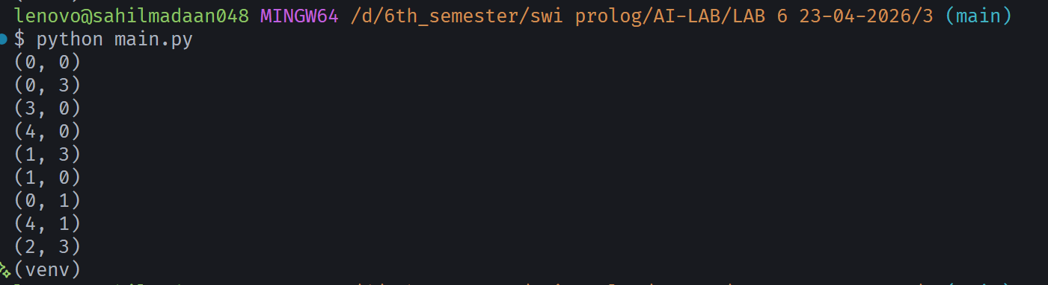

Lab 6
- Water Jug Problem Using Best First Search
You are given two water jugs:
Jug 1 capacity = 4 liters
Jug 2 capacity = 3 liters
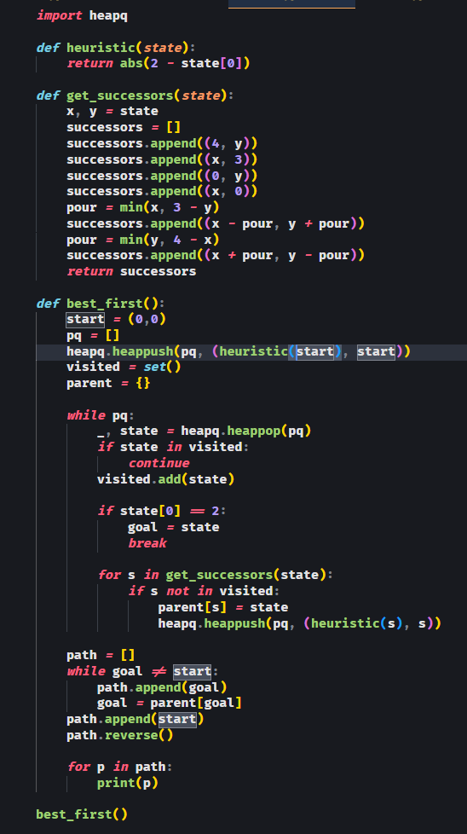
Initially both are empty. Goal: Measure exactly 2 liters in the 4-liter jug.

OUTPUT:

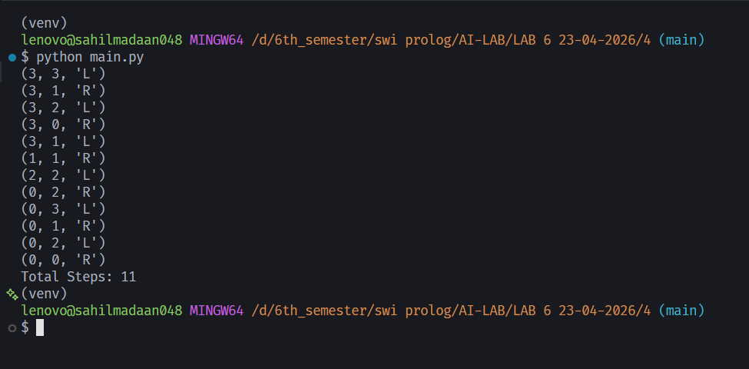

Lab 6
- Missionary-Cannibal Problem Using Best First Search
Three missionaries and three cannibals are on the left bank of a river.
A boat is available that can carry at most 2 people at a time.
Rules:
1. The boat cannot cross the river empty.
2. At no time on either bank should cannibals outnumber missionaries, unless there are zero missionaries on that bank.
3. The goal is to move all missionaries and cannibals to the right bank safely.
